**Newsletter no. 27 Spring Term – Friday 1st April 2022**



Dear Parents and Carers,

We have certainly had an extremely busy week at Witley. On Monday we held our Easter Service in the school grounds followed by parent/carer consultations. On Wednesday our Easter Pause day for our children enabled us to reflect on the Easter story and yesterday we walked over to All Saints Church where Year 2 told the Easter story. It was lovely to see so many of you join us.

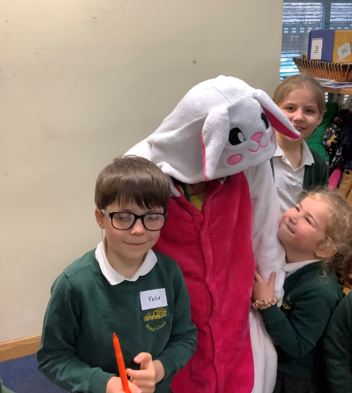

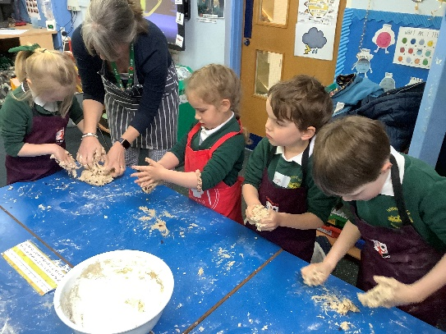

INSET DAYS for 2022/23

We have aligned next year’s Inset days with The Chandler School and the Godalming Learning Partnership and they are as follows:

Thursday 1st September and Friday 2nd September

Friday 10th February 2023, Monday 17th April 2023, Friday 26th May 2023

Please also see an attached open letter to all parents and carers from Surrey County Council’s Director of Public Health and Director of Education and Lifelong Learning.

Finally please don’t forget to check the lost property box outside Penguin Class.

Happy Easter everyone, see you all back at school on Wednesday, 20th April 2022.



Mrs Szczepanski

**News from Mrs Stratford, our Witley Maths Lead**



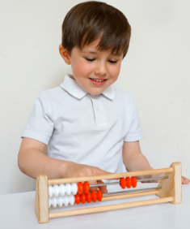We are very excited to be taking part in the NCETM Mastering Number project this summer and our rekenreks have arrived already!

This project aims to secure firm foundations in the development of good number sense for all children from Reception through to Year 1 and Year 2. The aim over time is that children will leave KS1 with fluency in calculation and a confidence and flexibility with number. Attention will be given to key knowledge and understanding needed in Reception classes, and progression through KS1 to support success in the future.

_______________________________________________________________________________

Thank you to those parents who have joined and logged into our new parent portal on Arbor. The parent portal is a fantastic way for parents to engage

with the school and if you have not yet joined, we’d very much like you to. Please can you refer to the email sent with your user name and password for instructions of how to join. If you are having difficulties logging on or need any assistance please do let the school office know and they will be very happy to help.

________________________________________________________________________________

**The Hen House Wraparound Care – Job opportunity**

RECRUITMENT- Are you an enthusiastic and caring person who might like to join our team running the breakfast and after school club? Flexible shifts at good rates of pay. Positions are available at Grayswood CofE Primary, Witley CofE Infant & St. Mary’s CofE Infant School in Shackleford. If interested please send an email to Catherine on - [care@thehen-house.com](mailto:care@thehen-house.com)”

**Cake raffle winner!**

This week’s winner is class Alice G in Penguins.

Thank you to Rosie Smith’s family for this week’s beautiful Easter cake.

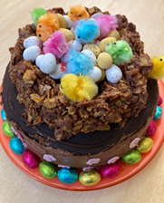

**Well done** to the following children who are in our Gold Book this week.

Dolphins: Charlotta and Oskar K

Penguins: Thomas, Maggie and Jack

Puffins: Shannon and Matilda

Headteacher’s Gold Book Award: Oscar H in Dolphins



**PENGUINS are collecting bottle tops. Can you help them?**

Penguin Class are collecting bottle tops from milk and juice containers to create artwork to enter a competition. We need as many as possible. Please drop them in the bucket outside Penguin Class. Thank you!

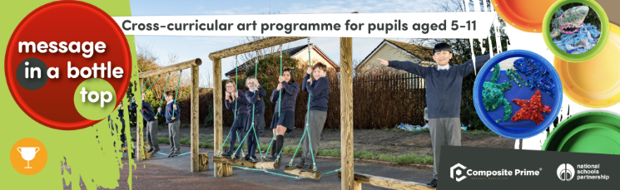

Once they have created their artwork at the end of May they will enter it into the Message in a Bottle Top competition to win a £5000 playground makeover! Good luck Penguin Class.

**PUFFINS BOOK SALE for all Classes**

Charlie in Puffin Class wanted to raise some money for the school to buy some new resources and he has come up with the idea of holding a Book Sale every Friday in the playground. I spoke with Puffins Class this week and they were very excited about the idea of holding a sale. The children will take it in turns to run the stall from 3 pm every Friday starting on Friday 22nd April.

Puffins Class are invited to bring in their old books for the sale. PLEASE ensure the books donated are appropriate for age 4 -7 years. Thank you.



We are very excited to announce that we are now working with The Ink Bin- a specialist teacher-led business which supports pupils to collect empty inkjet printer cartridges.

The Ink Bin pledge to recycle as much of the single-use plastic as possible and also send away some cartridges for refilling in order to reduce their carbon miles. For refillable cartridges, the company will give the school money which we can spend on exciting new equipment.

Please do check at home and at work to see if you have any old cartridges which can be brought into school - every cartridge makes a difference!

Please not we cannot accept large toner cartridges.

**NEWS FROM FWS**

Although this term was a quiet one for FWS, between the fabulous effort that the children put in for Break the Rules day in January and the yummy Krispy Kreme sale in February we have managed to raise £391, which is fantastic for our little school.

After Easter we have plenty of fun events, not just for fund-raising but also for fun! We’re planning to celebrate the Queen’s Jubilee, have an afternoon of fun with the Swashbuckle Challenge, Finally we have our Hawaiian Fete and say a, probably, tearful goodbye to our wonderful Puffins parents at the leavers dinner. Oh and there will be ice cream!

Once again a thank you must go out to all the parents for supporting us to fundraise for the school, we couldn’t do it without you! More details and dates for events will come out once we return for the summer term!

Enjoy the Easter Break Amanda, Tiff, Jo, Sam & Liz



**Calendar**

**\*Tuesday 19th April – INSET DAY 4**

Wednesday 20th April – Return to School

Monday 2nd May – **BANK HOLIDAY MONDAY**

**SUNDAY 22nd May – Jubilee Tea between 2 – 5 pm in the school grounds (FWS)**

Thursday 26th May – School finishes for half term

**\*Friday 27th May** – **INSET DAY 5** before half term

Half term - Monday 30th May - Friday 3rd June

**SUMMER TERM 2022**

Monday 6th June – Return to school

Thursday 9th June – Open Classrooms between 2.45 – 3.30 pm

Friday 17th June – FWS Swashbuckle Challenge

Tuesday 28th June – Dolphins Class to visit Tuesley Farm

Saturday 16th July – FWS Hawaiian Fete 12 – 3pm

**Friday 22nd July – End of term for the summer EARLY FINISH 1.30 pm**

**AUTUMN TERM 2022**

**\*Thursday 1st September – INSET DAY 1 and Friday 2nd September – INSET DAY 2**

Monday 3rd September – School starts for Year 1 and Year 2/Home visits for new Year R

Tuesday 4th September – Home visits for new Year R

Wednesday 5th September – Home visits for new Year R

End of term - Friday 21st October – End of term

**Half term - Monday 24th – Friday 28th October**

Start of term - Monday 31st October – Start of term

End of term - Friday 16th December – **EARLY FINISH 1.30 pm**

**SPRING TERM 2023**

Start of term -Tuesday 3rd January – Start of term

**\*Friday 10th February – INSET DAY 3**

**Half term – Monday 13th – Friday 17th February – Half term**

Start of term - Monday 20th February – Start of term

End of term - Thursday 31st March – **EARLY FINISH 1.30 pm**

**\*Monday 17th April – INSET DAY 4**

**SUMMER TERM 2023**

Start or term - Tuesday 18th April – Start of term

End of term Thurs 25th May – End of term

**\*Friday 26th May – INSET DAY 5 before half term**

**Half term – Monday 29th May – Friday 2nd June**

End of term - 21st July - **EARLY FINISH 1.30 pm**